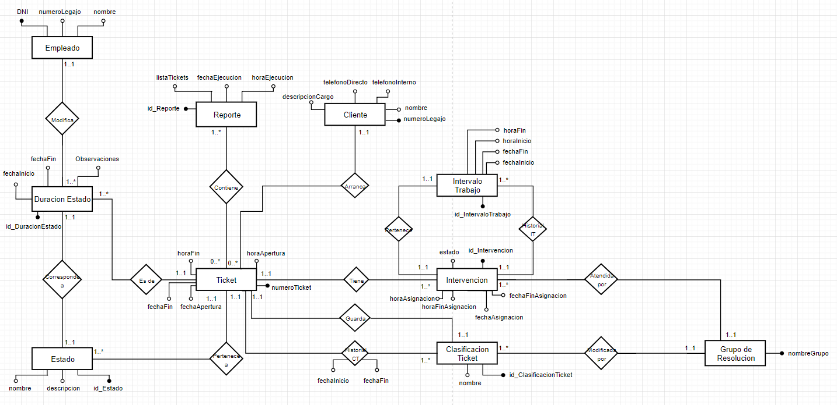

**EMPLEADO**

|  |  |  |
| --- | --- | --- |
| DNI (PK) | numeroLegajo | nombre |
|  |  |  |

**DURACION_ESTADO**

|  |  |  |  |  |  |
| --- | --- | --- | --- | --- | --- |
| id_DuracionEstado (PK) | fechaInicio | fechaFin | Observaciones | DNI (FK) | NumeroTicket (FK) |
|  |  |  |  |  |  |

**ESTADO**

|  |  |  |  |  |
| --- | --- | --- | --- | --- |
| id_Estado (PK) | nombre | descripcion | NumeroTicket (FK) | id_DuracionEstado (FK) |
|  |  |  |  |  |

**TICKET**

|  |  |  |  |  |  |
| --- | --- | --- | --- | --- | --- |
| numeroTicket (PK) | fechaApertura | fechaFin | horaApertura | horaFin | numeroLegajo (FK) |
|  |  |  |  |  |  |

**REPORTE**

|  |  |  |  |
| --- | --- | --- | --- |
| id_Reporte (PK) | listaTickets | fechaEjecucion | horaEjecucion |
|  |  |  |  |

**CLIENTE**

|  |  |  |  |  |
| --- | --- | --- | --- | --- |
| numeroLegajo (PK) | nombre | telefonoInterno | telefonoDirecto | descripcionCargo |
|  |  |  |  |  |

**INTERVENCION**

|  |  |  |  |  |  |  |  |
| --- | --- | --- | --- | --- | --- | --- | --- |
| id_Intervencion (PK) | estado | horaAsignacion | horaFinAsignacion | fechaAsignacion | fechaFinAsignacion | nombreGrupo (FK) | numeroTicket (FK) |
|  |  |  |  |  |  |  |  |

**INTERVALO_TRABAJO**

|  |  |  |  |  |  |
| --- | --- | --- | --- | --- | --- |
| id_IntervaloTrabajo (PK) | fechaInicio | fechaFin | horaInicio | horaFin | id_Intervencion (FK) |
|  |  |  |  |  |  |

**CLASIFICACION_TICKET**

|  |  |  |  |
| --- | --- | --- | --- |
| id_ClasificacionTicket (PK) | nombre | nombreGrupo (FK) | numeroTicket (FK) |
|  |  |  |  |

**GRUPO_DE_RESOLUCION**

|  |
| --- |
| nombreGrupo (PK) |
|  |

**HISTORIAL_CT**

|  |  |  |  |
| --- | --- | --- | --- |
| Numero (PK – FK) | Id_ClasificacionTicket (PK – FK) | fechaInicio | fechaFin |
|  |  |  |  |

**CONTIENE**

|  |  |
| --- | --- |
| id_Reporte (PK – FK) | numeroTicket (PK – FK) |
|  |  |